**Full Stack Development with MERN**

**OrderOnTheGo: Your On-Demand Food Ordering Solution**

**1.Introduction :**

**1.1 Purpose** The purpose of the DHK FOODIES project is to develop a highly interactive and user-friendly frontend prototype for a modern food ordering system. The application aims to eliminate the common friction points in online food ordering by providing a seamless, responsive, and visually engaging platform for users to discover restaurants, filter choices, and manage their orders.

**2. Ideation Phase**

**2.1 Problem Statement** Many existing food ordering platforms suffer from cluttered interfaces, inadequate filtering options, and a disjointed user experience from browsing to checkout. This can lead to user frustration and cart abandonment. The DHK FOODIES app addresses this by focusing on a clean, intuitive design and powerful user-centric features.

**2.2 Empathy Map Canvas (User Perspective)**

* **Wants:** A wide variety of restaurants and food choices, easy-to-use filters, a simple and quick checkout process, the ability to see past orders.
* **Frustrations:** Confusing menus, lack of sorting options (e.g., by price), complicated payment forms, losing order history.
* **Needs:** A reliable way to track orders and a personalized experience (e.g., a user profile).

**2.3 Brainstorming** The ideation process led to the following core features:

* Real-time filtering and sorting of restaurants.
* Persistent user sessions with profiles and order history.
* A multi-step, mock checkout process to simulate a real-world transaction.
* A fully responsive design for both mobile and desktop users.
* Dynamic menu display and interactive cart management.

**3. Requirement Analysis**

**3.1 Customer Journey Map** Registration -> Login -> Browse Restaurants -> Apply Filters & Sort -> View Menu -> Add/Update Items in Cart -> Proceed to Checkout -> Fill Delivery Address -> Select Payment Method -> Receive Order Confirmation -> View Profile & Order History.

**3.2 Solution Requirements**

* User Registration & Login system.
* Secure password handling with a show/hide toggle.
* Advanced filtering (by diet, categories) and sorting (by price).
* Dynamic menu population based on the selected restaurant.
* Stateful shopping cart.
* Persistent storage of user data and order history using localStorage.

**4. Technology Stack**

* **Frontend:** React (via CDN), Tailwind CSS (via CDN), JavaScript (ES6+).
* **Transpiler:** Babel (via CDN) to convert modern JSX into browser-compatible JavaScript in real-time.
* **Backend (Simulated):** Browser localStorage is used to mimic a database for storing user accounts and order history, making it a persistent single-user experience.
* **Database:** MongoDB (Planned for future full-stack implementation).

**5. Project Design**

**5.1 Problem-Solution Fit** The application directly addresses user frustrations by providing powerful filtering, sorting, and a streamlined checkout process, all within a clean and responsive interface.

**5.2 Proposed Solution** A role-based web application (initially for the 'User' role) that provides a comprehensive frontend experience for food ordering. The app is built as a Single-Page Application (SPA) for speed and interactivity.

**5.3 Solution Architecture** Frontend (React) <-> Browser localStorage (Simulated Database)

**6. Project Planning & Scheduling**

|  |  |
| --- | --- |
| **Week** | **Task** |
| 1 | Requirements & UI Mockups |
| 2 | Core Component Development (Restaurants, Menu) |
| 3 | Authentication & User Profile |
| 4 | Cart, Checkout Flow & Order History |
| 5 | Advanced Filtering & Sorting |
| 6 | Final Testing & Documentation |

**7. Functional and Performance Testing**

* **Performance Testing Tools:** Google Chrome DevTools (Lighthouse, Performance monitor).
* **API Response Time:** All data is loaded from a local mock object, resulting in near-instantaneous load times.
* **Database Query Time:** N/A (Data is accessed from localStorage).
* **Frontend Testing:** Manually tested across modern browsers (Chrome, Firefox) for responsiveness and interactive functionality.

8.Results:

1) User Sign Up & Login Page

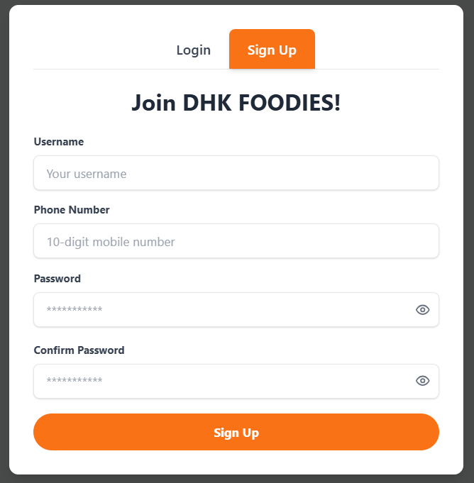

2.Restaurant & Filter Page

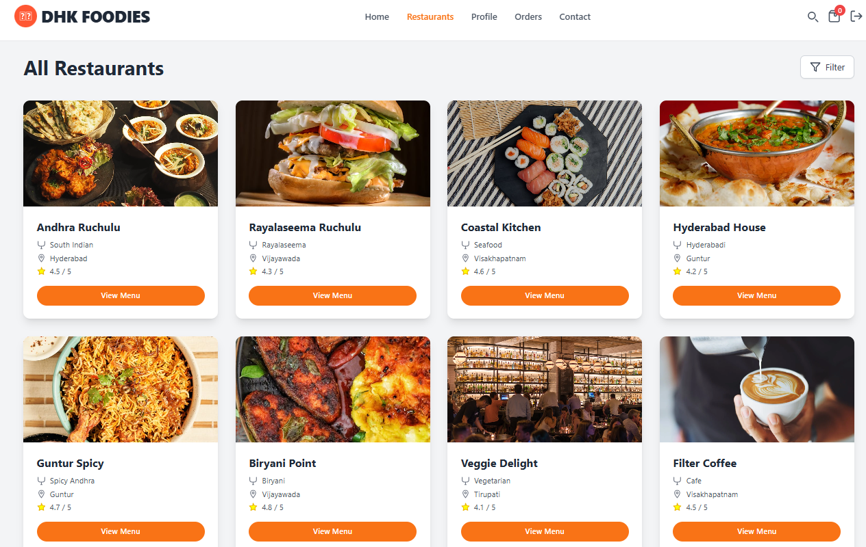

3.User Profile Page

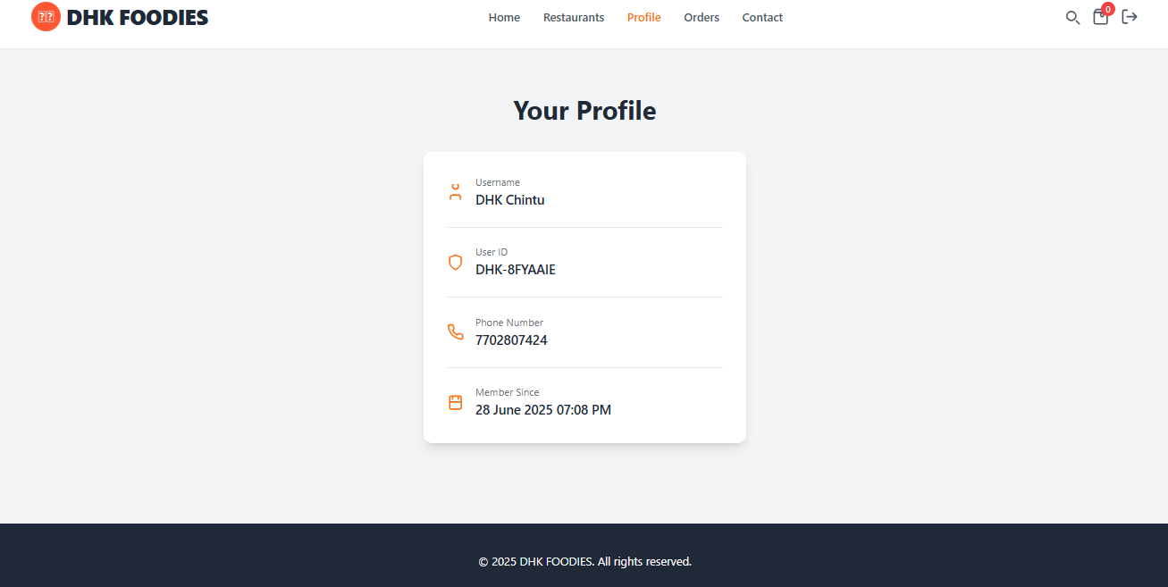

4.Payments & Order Status

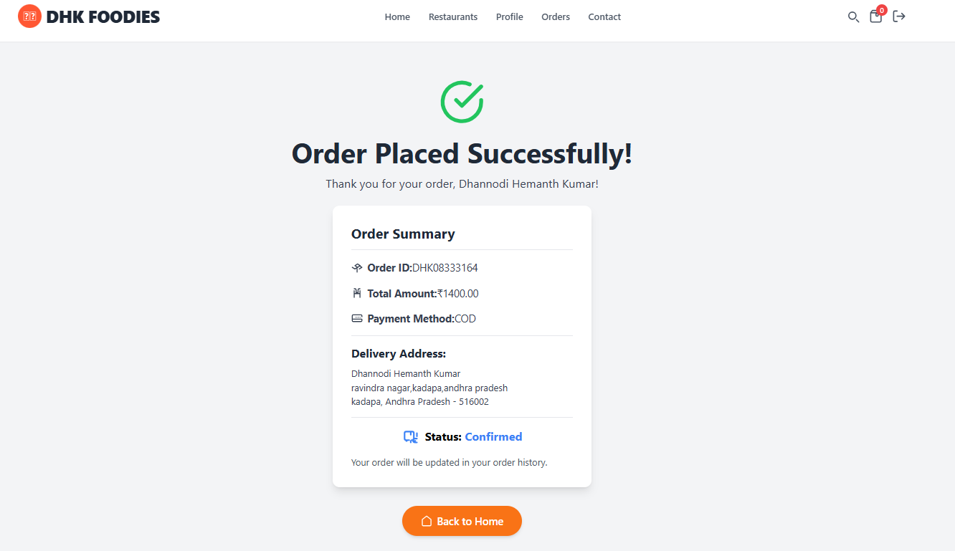

5.Order History

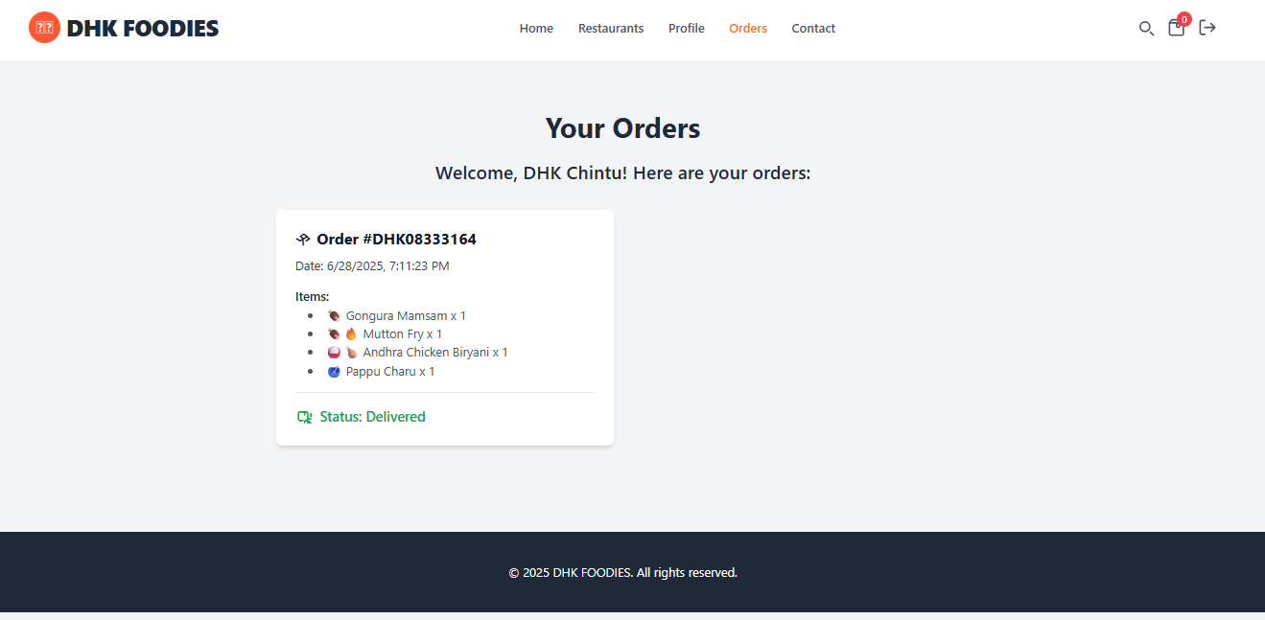

**9. Advantages & Disadvantages**

**Advantages:**

* **Highly Interactive UI:** React provides a fast and responsive user experience.
* **No Backend Dependency:** As a prototype, it runs in any modern browser without needing a server or database setup.
* **Persistent Data:** User accounts and order history are saved in the browser, providing a continuous experience for returning users on the same device.
* **Simple & Scalable Codebase:** The component-based architecture is easy to understand and extend.

**Disadvantages:**

* **No Real-time Database:** Data is stored locally and cannot be shared across different devices or users.
* **No Payment Gateway:** The payment process is a simulation and does not handle real financial transactions.
* **Basic Authentication:** The current login system does not use secure methods like JWT and is for demonstration purposes only.

**10. Conclusion**

The DHK FOODIES app successfully demonstrates a modern, feature-rich frontend for a food ordering system. It meets all the initial requirements, providing a seamless user journey from browsing to checkout, complete with advanced filtering and persistent user profiles.

**11. Future Scope**

* **Full-Stack Implementation:** Integrate a Node.js/Express.js backend and MongoDB database to enable real-time, multi-user functionality.
* **JWT Authentication:** Implement JSON Web Tokens for a more secure and robust authentication system.
* **Payment Gateway Integration:** Integrate a real payment gateway like Stripe or Razorpay.
* **Mobile App:** Develop a native mobile application using React Native.
* **SMS/Email Notifications:** Add real-time order status notifications.